**Practical-4**

**AIM: Understand and identify Layer-2 functionality.**

**---------------------------------------------------------------------------------------------------------------------------**

Tools required:

1. Desktop Computer
2. Cisco Packet Tracer

Simulate different scenarios given below in Cisco packet tracker and fill up table.

**Note:** While applying IP address, student need to allocate IP address as per his/her student ID. For Example, if student ID is 20ce005 then IP address allocation for first network should start with 5.0.0.0. For subsequent network, it should start with ID+1 i.e. 6.0.0.0, 7.0.0.0. and so on.

**Submission**: After writing answer into this word document, Student need to change name to his ID followed by practical number. Ex 20ce005_Pr1.docx. Upload on assignment segment.

**Rubrics**: Nicely drafted document with clarity in answers leads to full marks. Otherwise, submission carries proportional mark.

**Recommended** to type, avoid copy-past to increase your typing skill.

**Exercise-1**

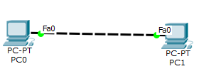

Redraw above diagram which includes IP address and MAC address. Take IP address and MAC address as per your knowledge.

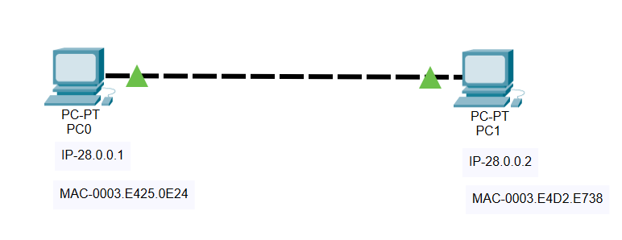

Write down ARP table of PC0 and PC1.

Fill ARP table entry of PC0

|  |  |
| --- | --- |
| **IP address** | **MAC Address** |
| 28.0.0.2 | 0003.E4D2.E738 |

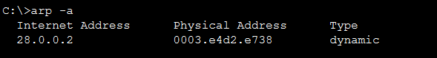

Fill ARP table entry of PC1

|  |  |
| --- | --- |
| **IP address** | **MAC Address** |
| 28.0.0.1 | 0003.E425.0E24 |



**Questions:**

1. What does ARP table contain?

**Ans:-** ARP table contains IP addresses and the resolved physical Layer2 MAC Addresses.

1. Why there is need of ARP table?

**Ans**:- ARP table is used to maintain a correlation between each MAC address and its corresponding IP address.

1. What is topology name of exercise-1?

**Ans**:- Point-to-point topology

1. What is relation of IP address with MAC address?

**Ans:** The main difference between MAC and IP address is that, MAC Address is used to ensure the physical address of computer. It uniquely identifies the devices on a network. While IP address are used to uniquely identifies the connection of network with that device take part in a network

1. Can we change MAC Address of machine?

**Ans**:- No, we cannot. It is coded in the NIC provided by the producer.

1. Can we change IP address of machine?

**Ans**:- Yes, we can.

**Exercise-2 :**

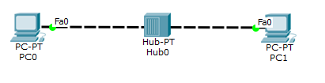

Redraw above diagram which includes IP address and MAC address. Take IP address and MAC address as per your knowledge.

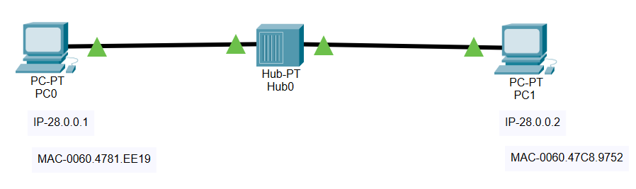

Write down ARP table of PC0 and PC1. Write down switch table of Hub0.

Fill ARP table entry of PC0

|  |  |
| --- | --- |
| **IP address** | **MAC Address** |
| 28.0.0.2 | 0060.47C8.9752 |



Fill ARP table entry of PC1

|  |  |
| --- | --- |
| **IP address** | **MAC Address** |
| 28.0.0.1 | 0060.4781.EE19 |



Fill Switch table entry of Hub0

|  |  |
| --- | --- |
| **MAC Address** | **Ethernet port no** |
| NA | NA |

Questions:

1. What is functionality of Hub?

**Ans:** A hub is a physical layer networking device which is used to connect multiple devices in a network. They are generally used to connect computers in a LAN.

1. Does hub have IP address?

**Ans**: No, Hubs don’t have IP address or a MAC address.

1. Does hub have switch (ARP) table?

**Ans:** No, Hubs don’t have ARP table because hub simply sends the packet to all the devices in the network instead of the particular destination as done by switch.

1. What is topology of exercise-2?

**Ans:** Star Topology

**Exercise-3**

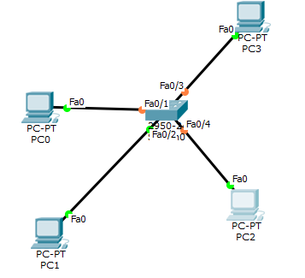

Redraw above diagram which includes IP address and MAC address. Take IP address and MAC address as per your knowledge.

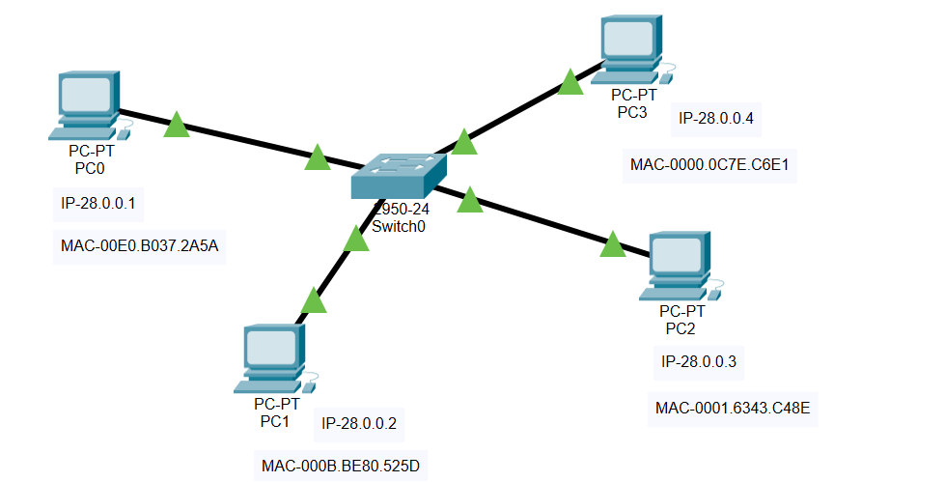

Write down ARP table of PC0 and PC1. Write down switch table of Hub0.

Fill ARP table entry of PC0

|  |  |
| --- | --- |
| **IP address** | **MAC Address** |
| 28.0.0.2 | 000B.BE80.525D |
| 28.0.0.3 | 0001.6343.C48E |
| 28.0.0.4 | 0000.0C7E.C6E1 |

Fill ARP table entry of PC1

|  |  |
| --- | --- |
| **IP address** | **MAC Address** |
| 28.0.0.1 | 00E0.B037.2A5A |
| 28.0.0.3 | 0001.6343.C48E |
| 28.0.0.4 | 0000.0C7E.C6E1 |

Fill ARP table entry of PC2

|  |  |
| --- | --- |
| **IP address** | **MAC Address** |
| 28.0.0.1 | 00E0.B037.2A5A |
| 28.0.0.2 | 000B.BE80.525D |
| 28.0.0.4 | 0000.0C7E.C6E1 |

Fill ARP table entry of PC3

|  |  |
| --- | --- |
| **IP address** | **MAC Address** |
| 28.0.0.1 | 00E0.B037.2A5A |
| 28.0.0.2 | 000B.BE80.525D |
| 28.0.0.3 | 0001.6343.C48E |

Fill Switch table entry of Switch0

|  |  |
| --- | --- |
| **MAC Address** | **Ethernet port no** |
| 0000.0C7E.C6E1 | FastEthernet0/4 |
| 00E0.B037.2A5A | FastEthernet0/3 |
| 000B.BE80.525D | FastEthernet0/2 |
| 0001.6343.C48E | FastEthernet0/1 |

Questions:

1. What is the functionality of switch?

**Ans**:- They manage the flow of data across a network by transmitting a received network packet only to the one or more devices for which the packet is intended.

1. Does the switch have an IP address?

**Ans**:- No.

1. Does the switch have a switch (ARP) table?

**Ans**:- Yes.

**4**.What is the topology name of exercise-3?

**Ans**:- Star Topology

**Exercise-4**

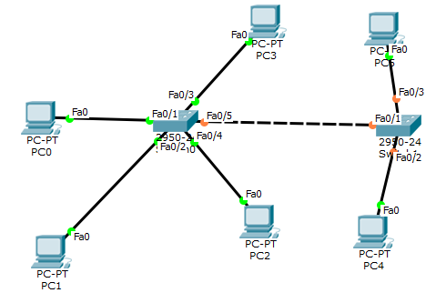

Redraw above diagram which includes IP address and MAC address. Take IP address and MAC address as per your knowledge.

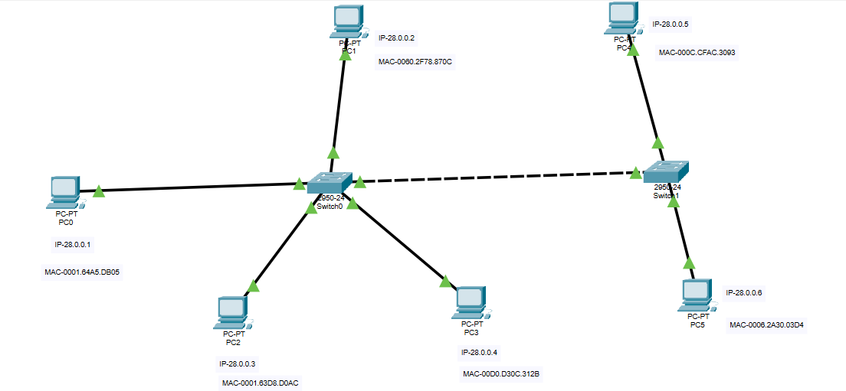

Write down ARP table of PC0 and PC1. Write down switch table of Hub0.

ARP table entry of PC0

|  |  |
| --- | --- |
| **IP address** | **MAC Address** |
| 28.0.0.2 | 0060.2F78.870C |
| 28.0.0.3 | 0001.63D8.D0AC |
| 28.0.0.4 | 00D0.D30C.312B |
| 28.0.0.5 | 000C.CFAC.3093 |
| 28.0.0.6 | 0006.2A30.03D4 |

ARP table entry of PC1

|  |  |
| --- | --- |
| **IP address** | **MAC Address** |
| 28.0.0.1 | 0001.64A5.DB05 |
| 28.0.0.3 | 0001.63D8.D0AC |
| 28.0.0.4 | 00D0.D30C.312B |
| 28.0.0.5 | 000C.CFAC.3093 |
| 28.0.0.6 | 0006.2A30.03D4 |

ARP table entry of PC2

|  |  |
| --- | --- |
| **IP address** | **MAC Address** |
| 28.0.0.1 | 0001.64A5.DB05 |
| 28.0.0.2 | 0060.2F78.870C |
| 28.0.0.4 | 00D0.D30C.312B |
| 28.0.0.5 | 000C.CFAC.3093 |
| 28.0.0.6 | 0006.2A30.03D4 |

ARP table entry of PC3

|  |  |
| --- | --- |
| **IP address** | **MAC Address** |
| 28.0.0.1 | 0001.64A5.DB05 |
| 28.0.0.2 | 0060.2F78.870C |
| 28.0.0.3 | 0001.63D8.D0AC |
| 28.0.0.5 | 000C.CFAC.3093 |
| 28.0.0.6 | 0006.2A30.03D4 |

ARP table entry of PC4

|  |  |
| --- | --- |
| **IP address** | **MAC Address** |
| 28.0.0.1 | 0001.64A5.DB05 |
| 28.0.0.2 | 0060.2F78.870C |
| 28.0.0.3 | 0001.63D8.D0AC |
| 28.0.0.4 | 00D0.D30C.312B |
| 28.0.0.6 | 0006.2A30.03D4 |

ARP table entry of PC5

|  |  |
| --- | --- |
| **IP address** | **MAC Address** |
| 28.0.0.1 | 0001.64A5.DB05 |
| 28.0.0.2 | 0060.2F78.870C |
| 28.0.0.3 | 0001.63D8.D0AC |
| 28.0.0.4 | 00D0.D30C.312B |
| 28.0.0.5 | 000C.CFAC.3093 |

Switch table entry of Switch0

|  |  |
| --- | --- |
| **MAC Address** | **Ethernet port no** |
| 0002.5AD9.AC01 | FastEthernet0/1 |
| 0002.5AD9.AC02 | FastEthernet0/2 |
| 0002.5AD9.AC03 | FastEthernet0/3 |
| 0002.5AD9.AC04 | FastEthernet0/4 |
| 0002.5AD9.AC05 | FastEthernet0/5 |

Switch table entry of Switch1

|  |  |
| --- | --- |
| **MAC Address** | **Ethernet port no** |
| 00F0.BA65.3E01 | FastEthernet0/1 |
| 00F0.BA65.3E02 | FastEthernet0/2 |
| 00F0.BA65.3E04 | FastEthernet0/4 |

Questions

1. Do both switches have identical switching tables?

**Ans**:- No. Switch Table of a Switch has MAC addresses of the other switches.

1. In Exercise-4, why does PC0 contain the IP MAC address of PC4?

**Ans**:- ARP of PC0 has IP MAC of PC4 because of Address Resolution Protocol. This is executed before ICMP to know the MAC of Destination with help of its IP Address.

1. What is the topology of exercise-4?

**Ans**:- Hybrid Star Topology (P2P of 2 Star LANs)